**Tools and Technology**



C#

C# licenses various types of irregular state tongues executable codes with Runtime condition as it is planned for fundamental language structure. It is moreover arranged with the section and even we can say it is a sorted out language.

Microsoft gives the accompanying advancement apparatuses to C# programming −

• (VS) Visual Studio 2010

• (VCE) Visual C# 2010 Express

• Visual Web Developer we

MYSQL

Customers are allowed to get to the data

Controls and portray the data in the information base we

Supplement inside various vernaculars will be allowed

Different supports can be embarked to the connected approach points of view and tables

Grants creation and the fundamental social occasion of data set and tables

**Install Visual studio**

**Step 1)** https://www.visualstudio.com/downloads/

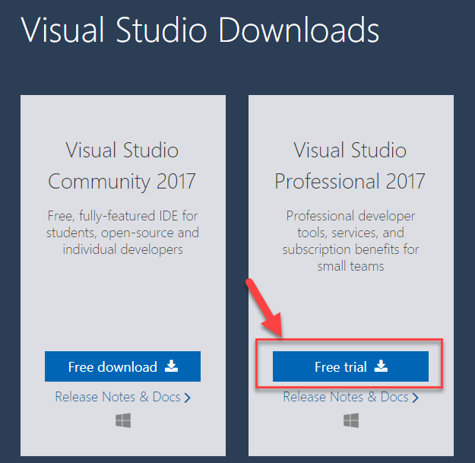

**Step 2)** Click on the downloaded exe file

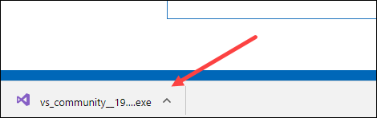

**Step 3)** In the next screen, click continue

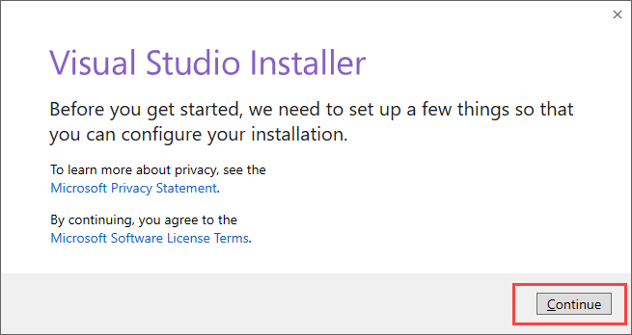

**Step 4)** downloading the initial files.

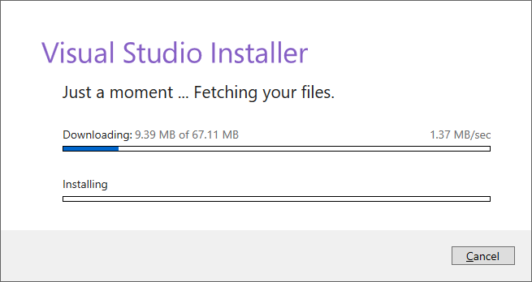

**Step 5)** In next screen, click install

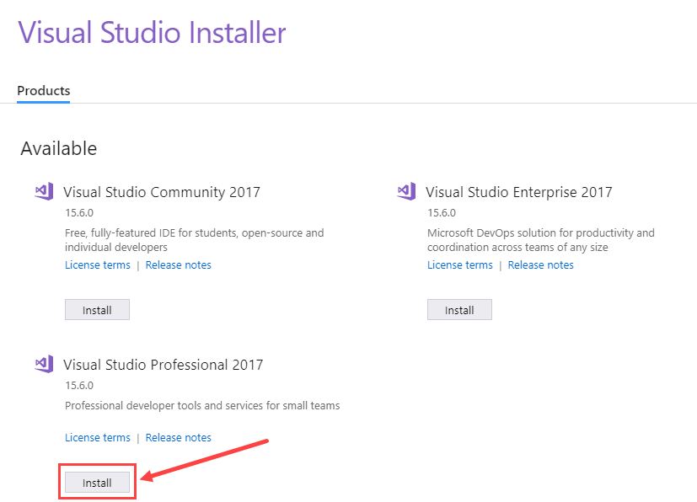

**Step 6)** In next screen,

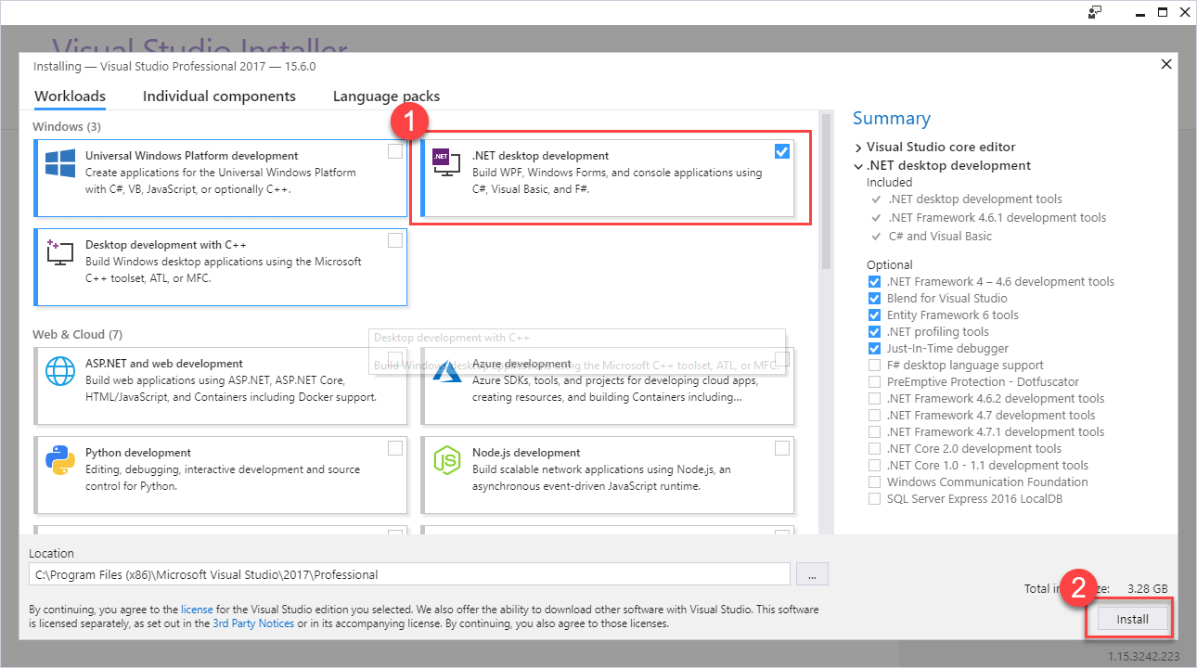

1. Select ".Net desktop development"
2. Click install

**Step 7)** download the relevant files

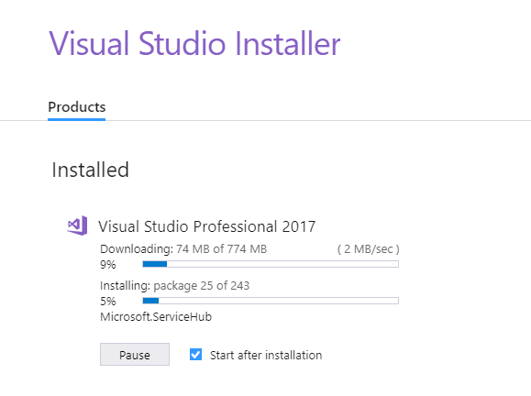

**Step 8)** Reboot the PC

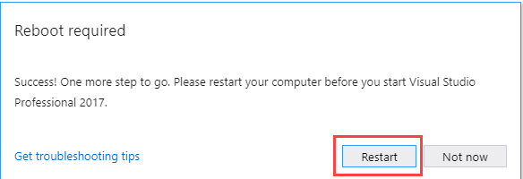

**Step 9)** Post reboot, open the Visual Studio IDE